Education Tutor functionality
  - User Experience Preview (proposed)

Overview
This document contains images of a working prototype of the proposed functionality in Stream to improve the user experience for Education Tutors.

Key features
The Education Tutor, using their Education Tutor login (st1nnnnn), can:
- Submit assignments on behalf of students through a central portal.
- Access the course as the student, without needing to log in as the student.
For normal Stream use, they will only need their Education Tutor login - not student credentials.
For the Education Tutor manager (i.e., Toni, Claire):
- Tutor/Student allocations are managed through a simple user interface.
- Education Tutors do not need to be enrolled in course sites.

Login Summary
- The Education Tutor account (st1nnnnn) is the primary Stream login credential. Through it, Education Tutors can access the support and training sites, as well as the specific Education Tutor functionality presented here.
- Student credentials can (or could) be used, but regular usage may be unnecessary.

Education Tutor experience
From their personal menu, they will see new options:
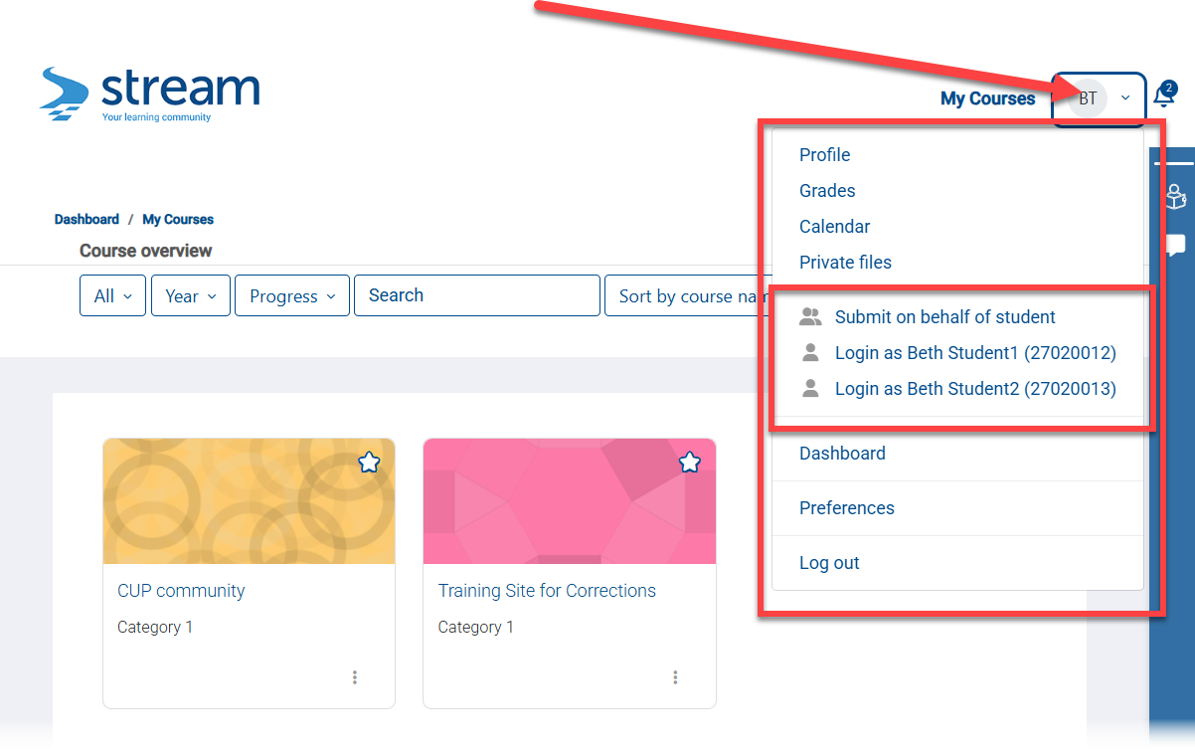

Submit on behalf of student option
Through a central portal, the Education Tutor can submit a standard assignment as the student without logging in as the student. That is, the Education Tutor will not need to enter the course, find the assignment, and navigate the submission interface.
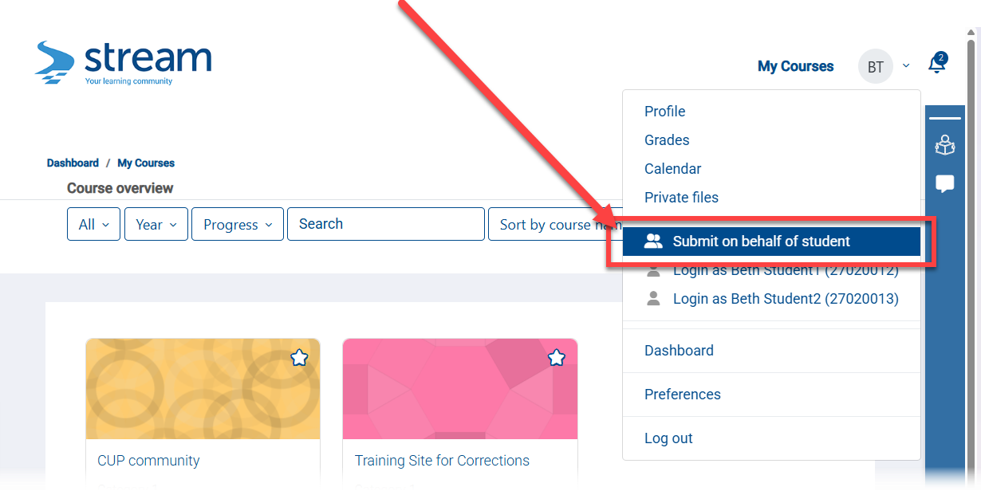
They are then guided to select the student (only their students), course (only the courses their students are in) and assignment (only the assignments in the selected course):
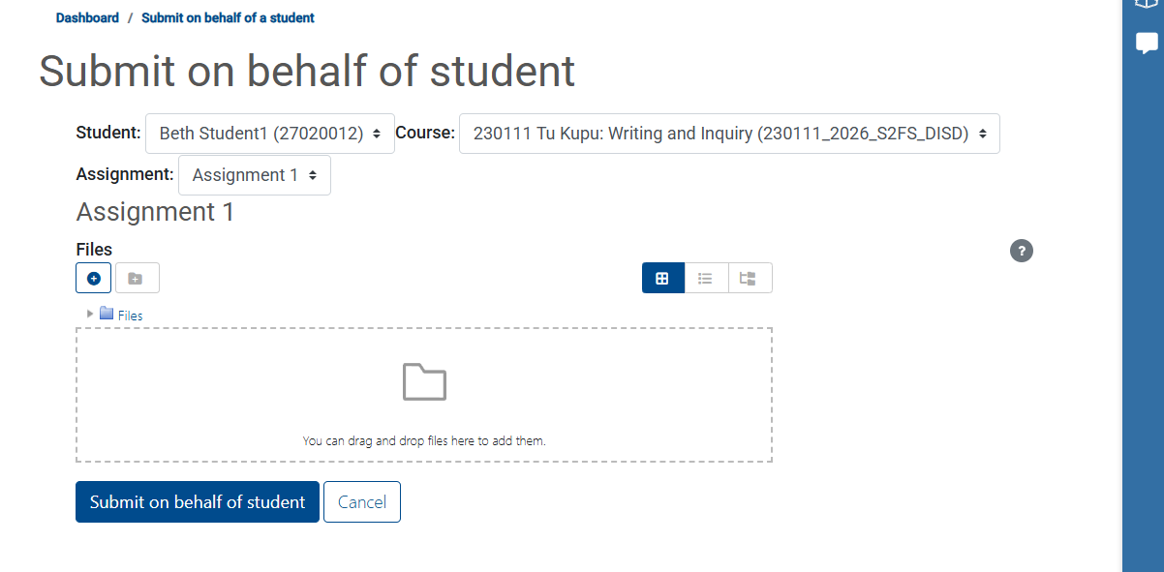
Once the file/s are upload and the Submit button is clicked, then a status screen appears:
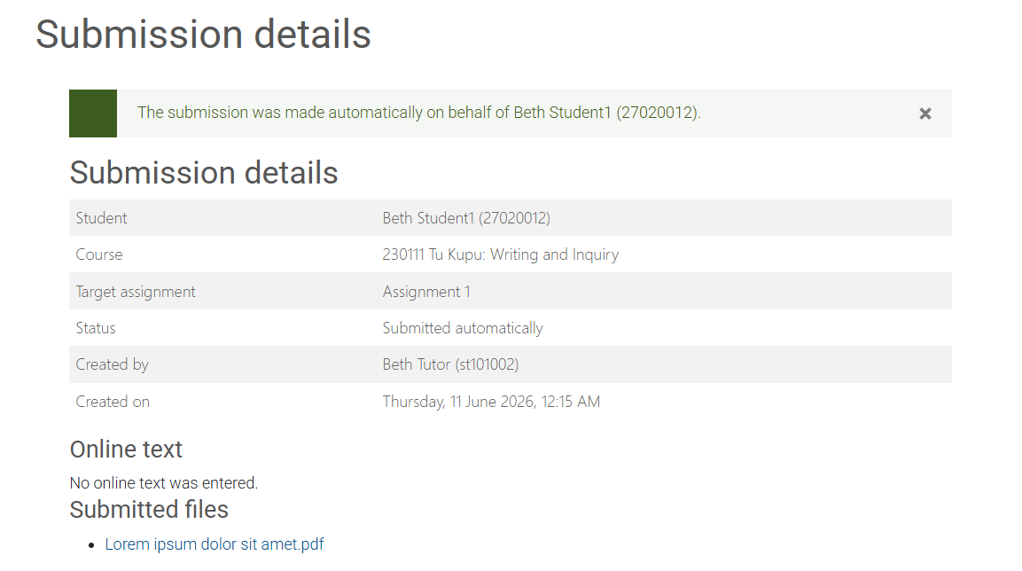

From a coordinator/teacher perspective, the assignment looks like a normal submission:
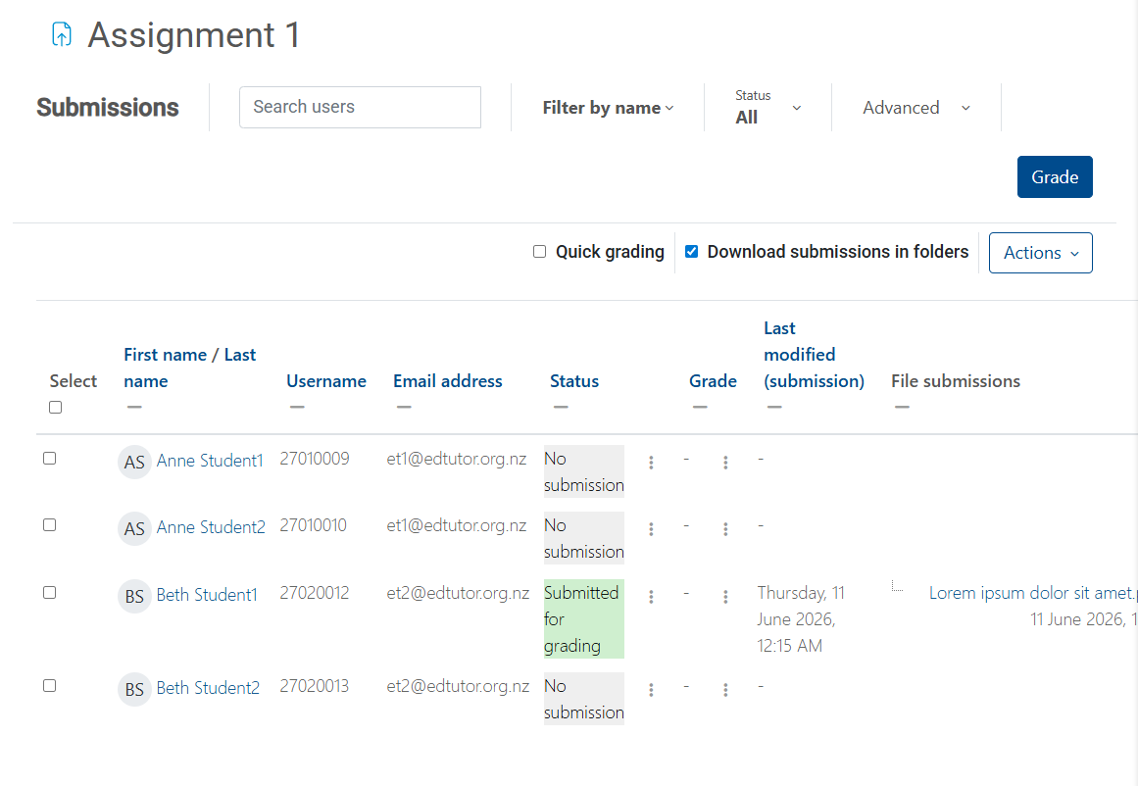
And there is full logging:
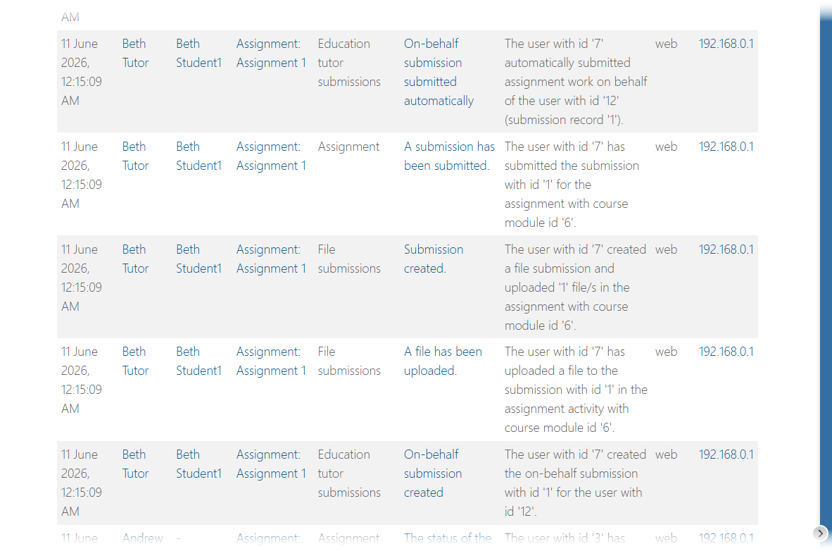

Loggin on in behalf
Education tutors can quickly “login as” any of their allocated students.
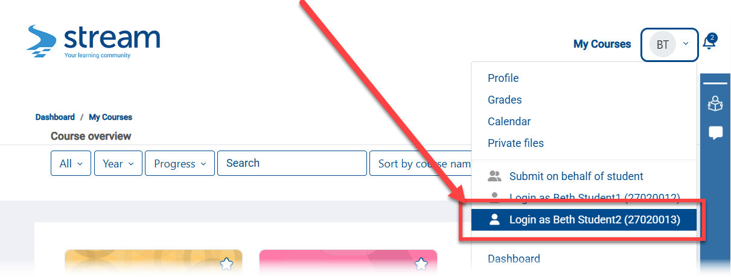

They can then see the students courses:
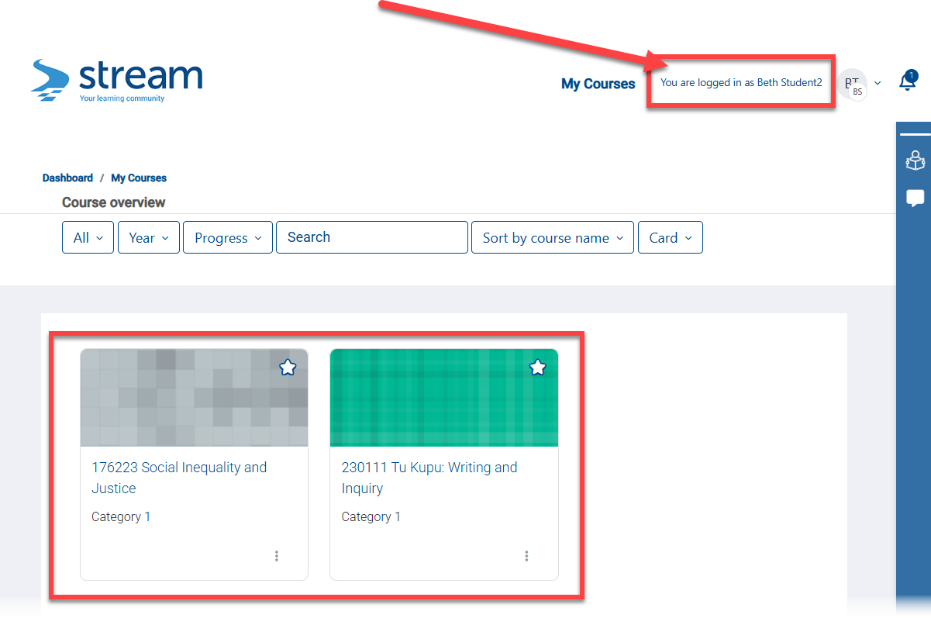

They can then engage with the course, view assignment feedback, and submit assignments directly.
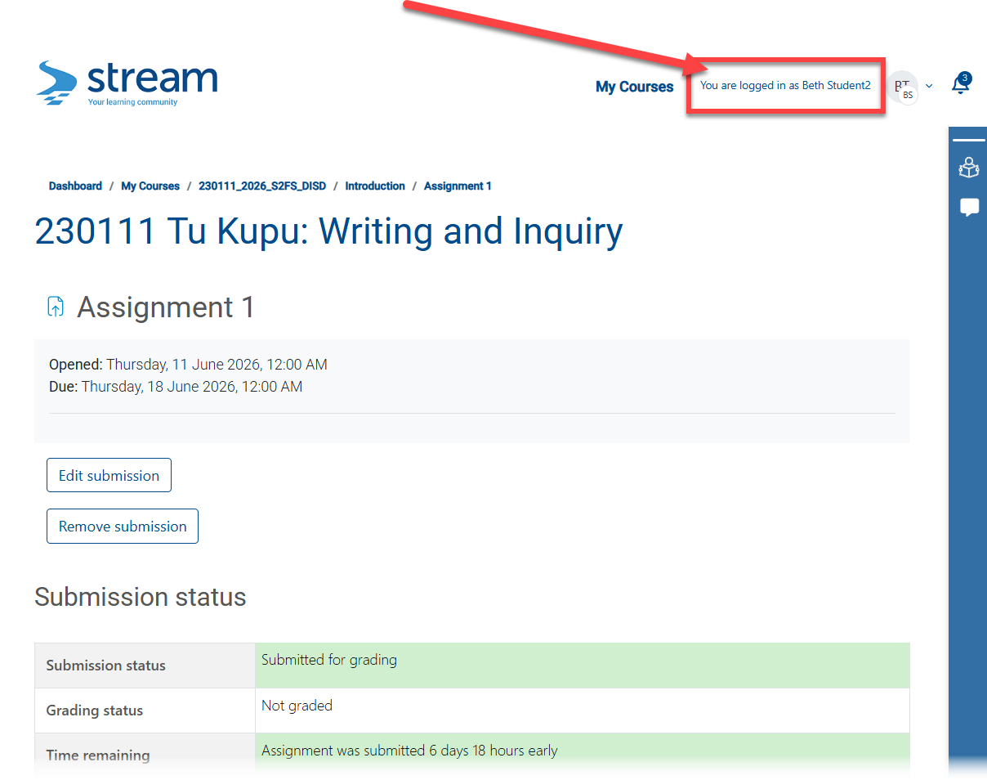

The Education Tutor can also directly login as another student without logging out or returning to their Education Tutor role:
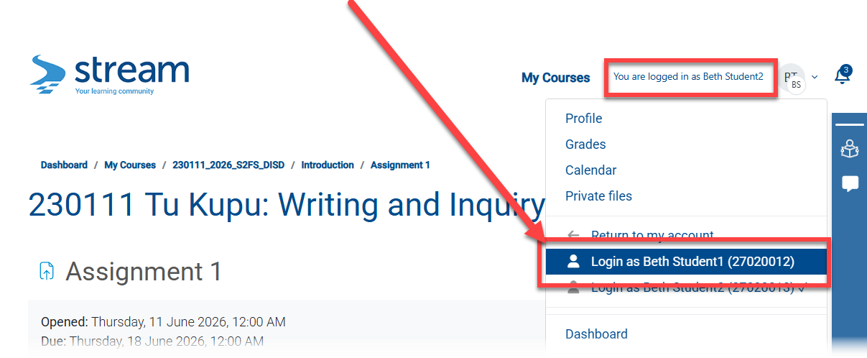

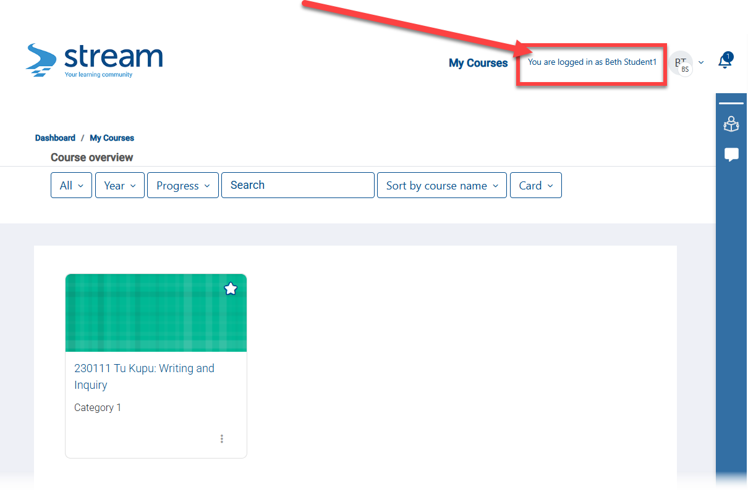

Or return to your Education Tutor role:
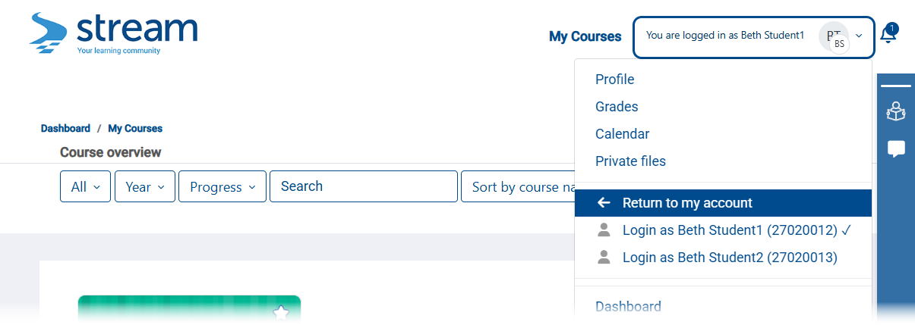

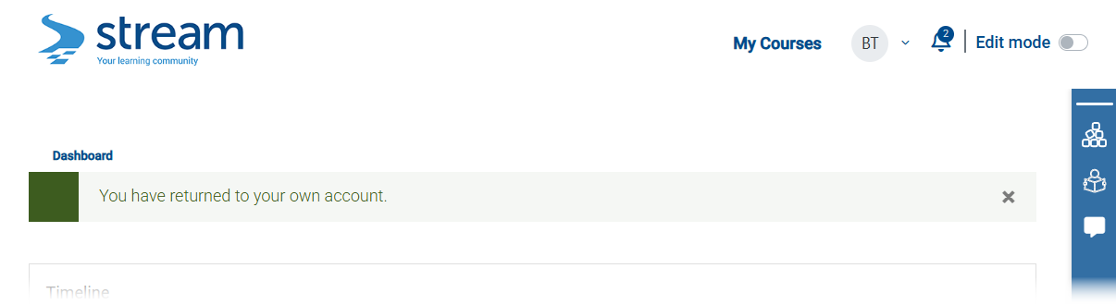

Education tutor manager experience

Tutor – Student Allocations
This feature is intended for central service units to administrator Education Tutors and their allocations. Multiple users can have this role, i.e., Claire, Toni, and others in the team.
Once tutors have been given an ST account and added to Stream, they can be linked to their students using a new administration screen.
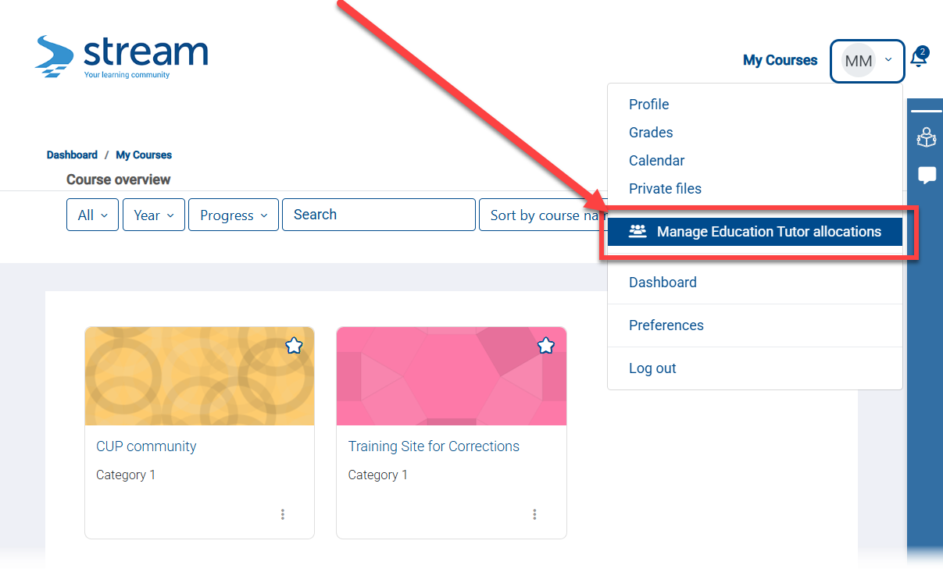
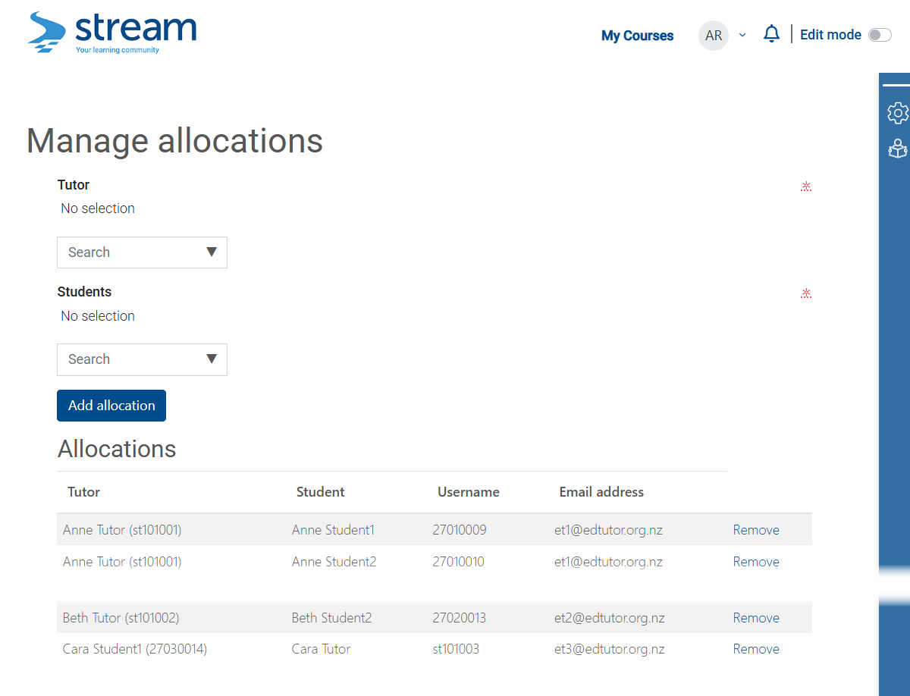

Stream support experience
Note: Only basic functionality has been worked up at this stage.
If submissions cannot be completed on behalf, the Education Tutor will be alerted at the time, and nominated support [Stream] staff will receive a message indicating that a submission requires manual intervention.
Education tutor view:
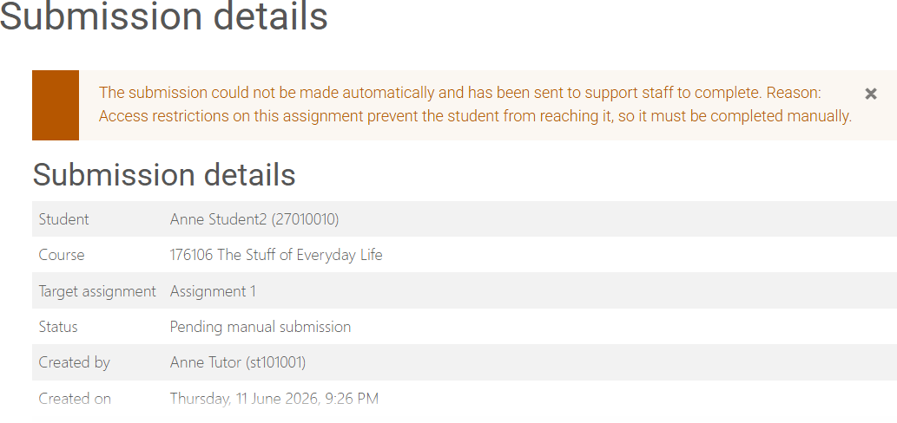

Support staff can access the submissions requiring manual intervention:
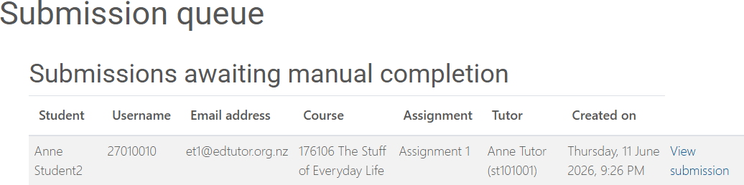

When viewed:
